**Year 8 Chemistry Test**

Student Name: Sienna Miranda

Goals:

* Sienna can draw, describe and identify examples of solids, liquids and gases.
* Sienna can give the symbol/name for most of the first 20 elements
* Sienna can identify elements, compounds and mixtures.

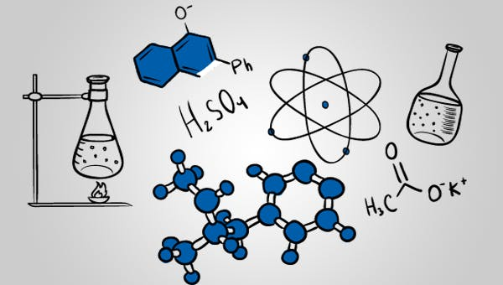

Teacher comment:

**Question 1**

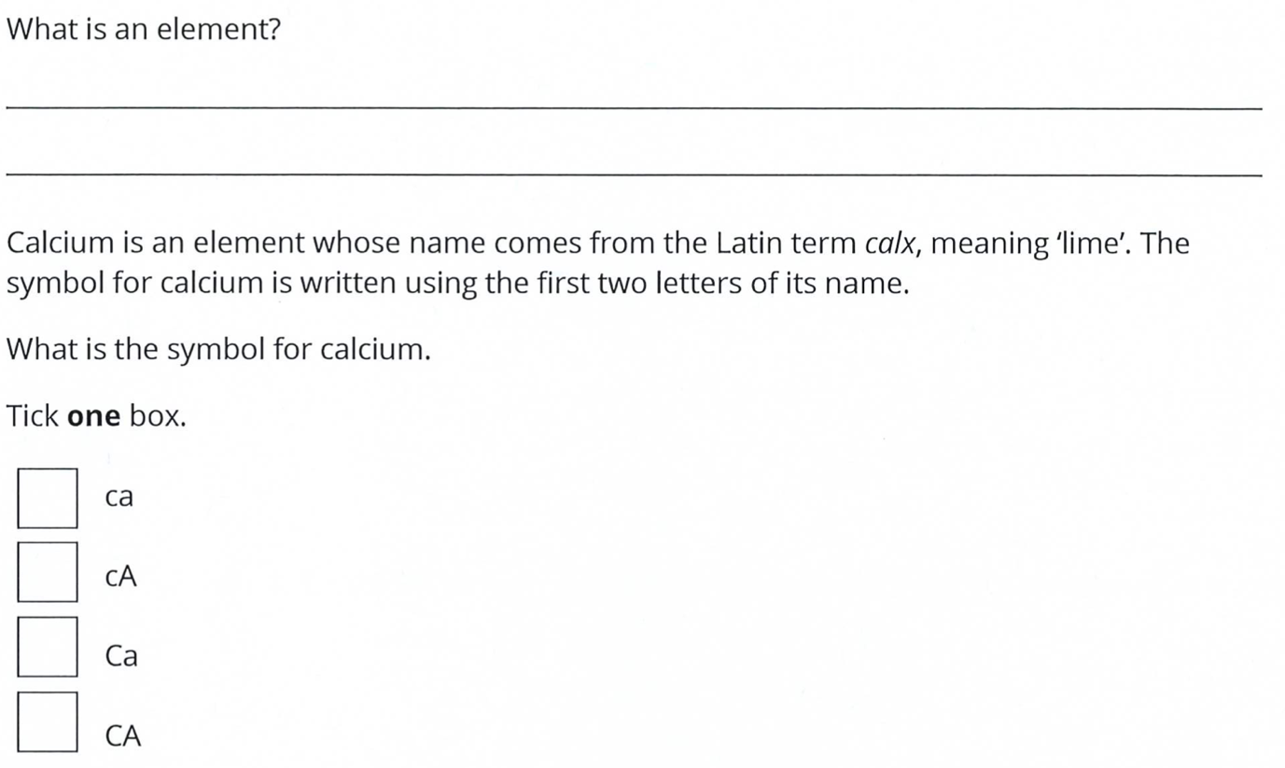

**Question 2**

**Question 3**

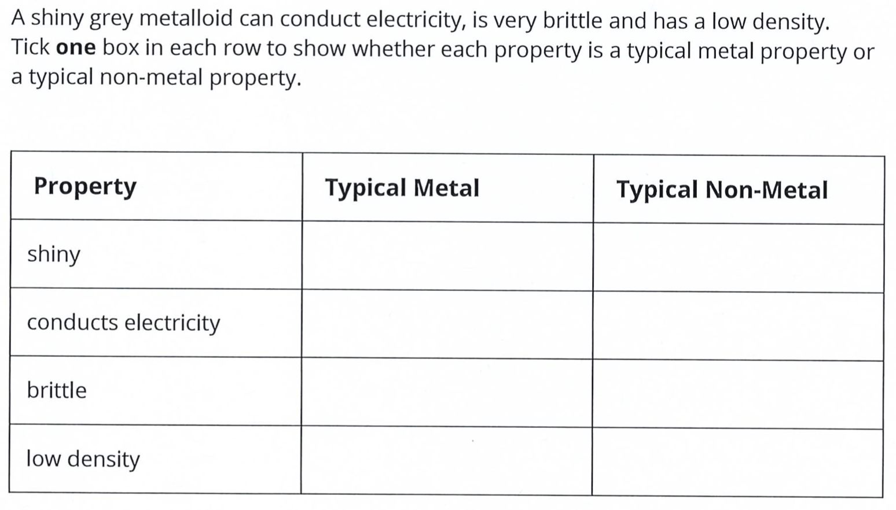

**Question 4**

Identify the change of state that is happening in each situation:

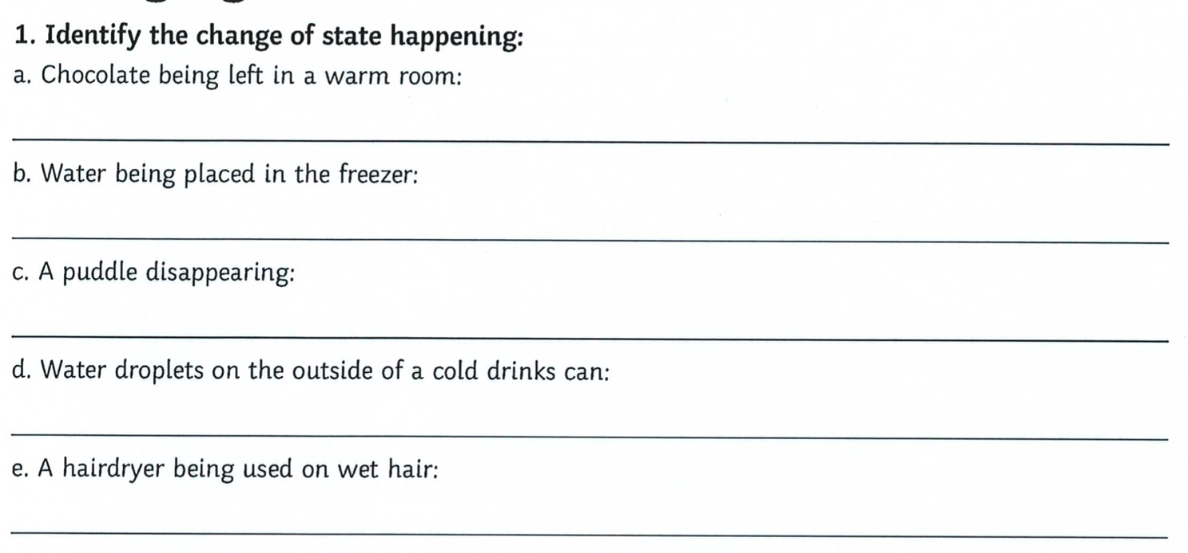

**Question 5**

In each box, write the change of state that is taking place:

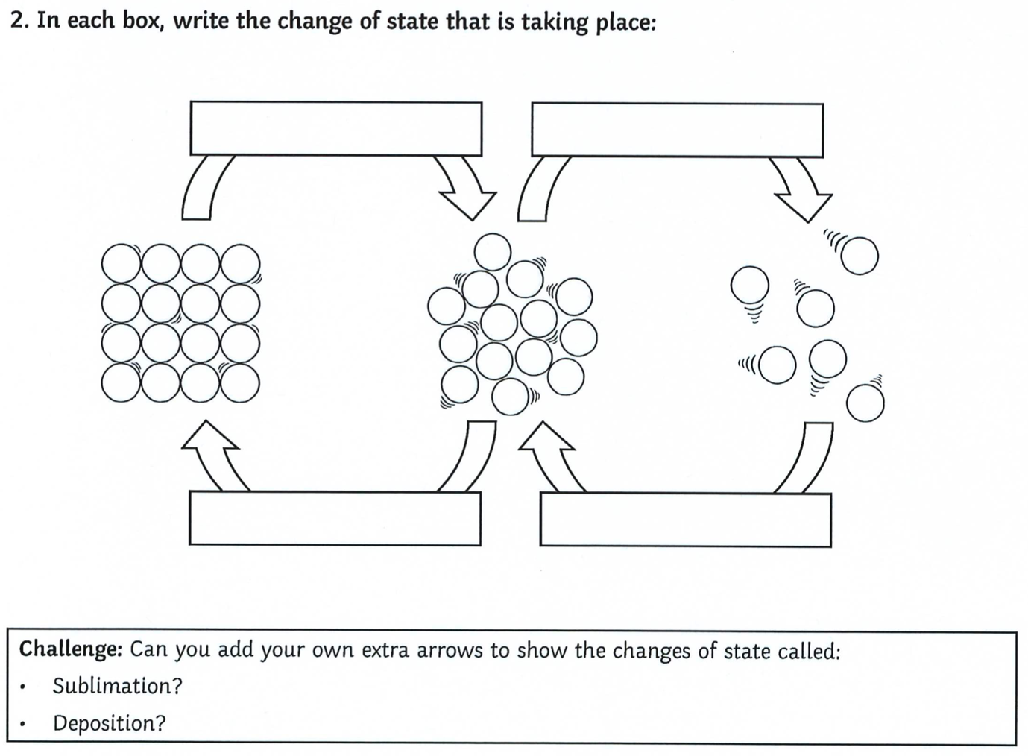

**Question 6**

Rahul takes a shower, makes a cup of tea and then hangs his washing outside to dry. For each scenario, identify the change(s) of state happening and describe what is happening to the water molecules.

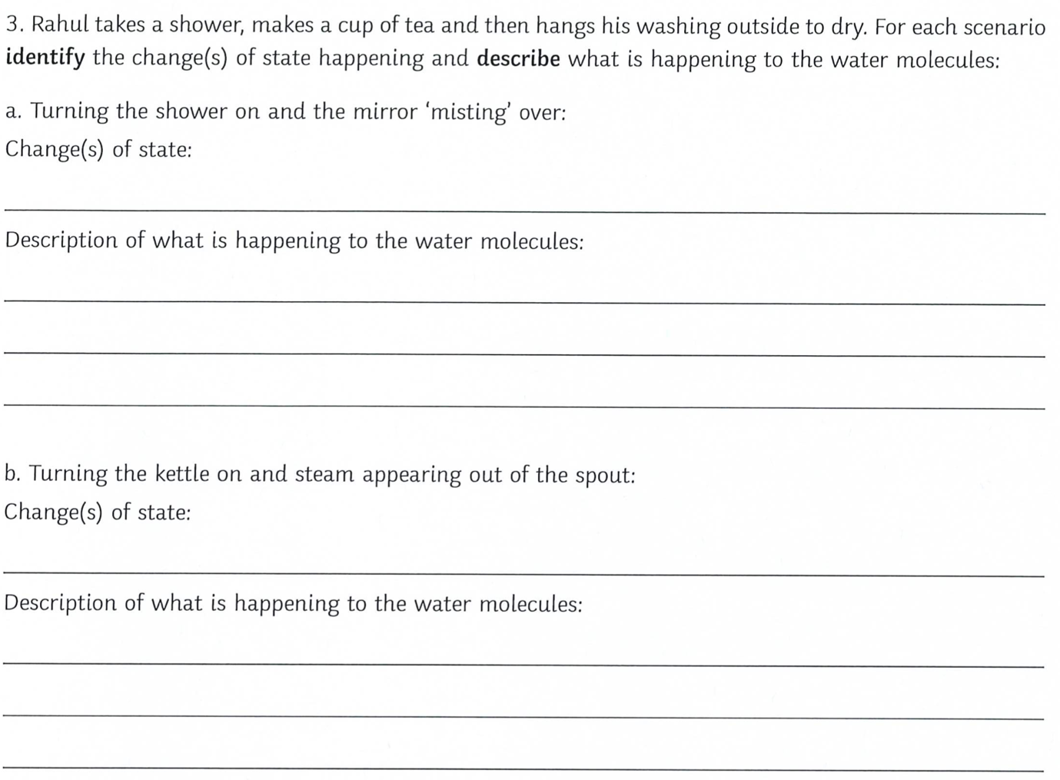

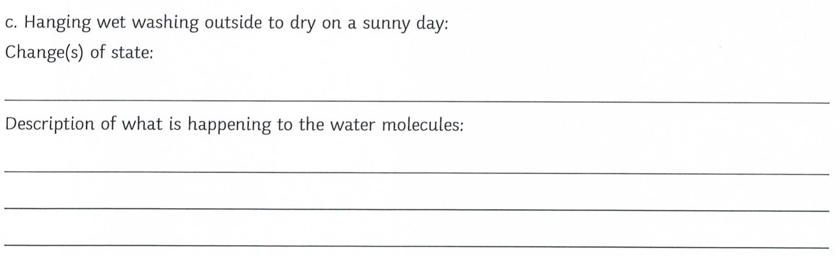

**Question 7**

For each property, explain why it is possible in terms of how the particles are arranged:

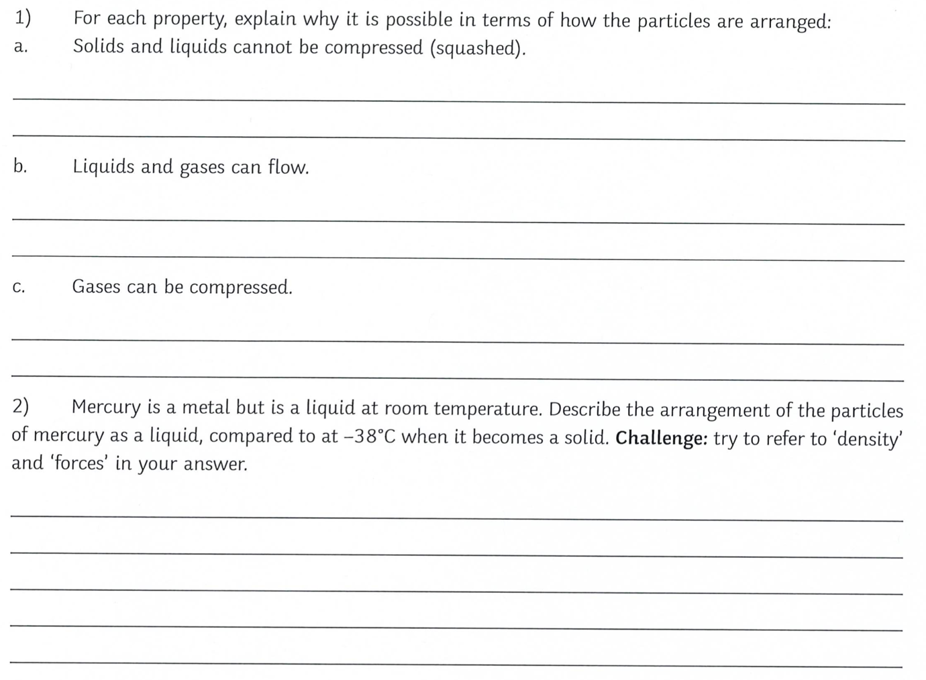

**Question 8**

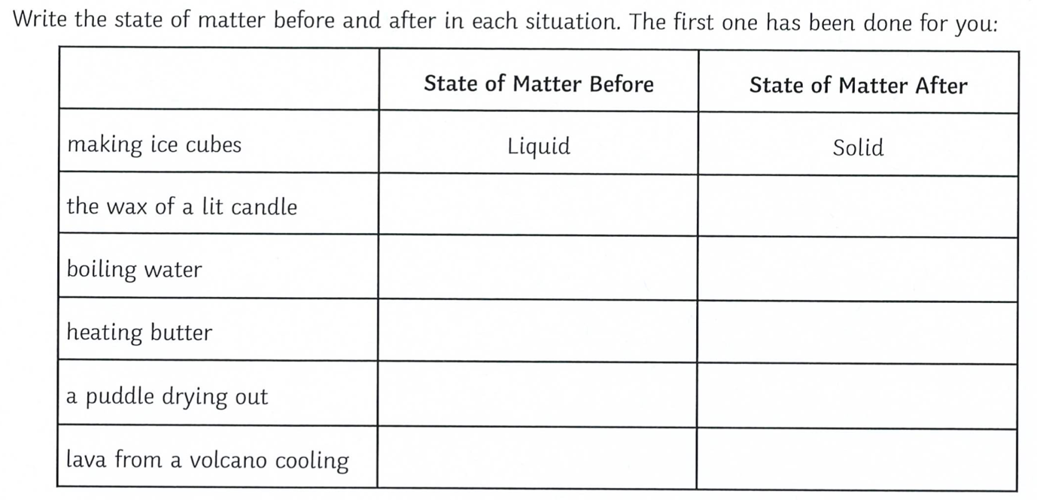

**Question 9**

1. How many protons, neutrons and electrons do each of the following atoms have?
2. For an extra challenge: Can you work out the atomic number and the atomic mass. Remember – the atomic number is number of protons in the nucleus, while the mass number is the number of protons plus the number of neutrons.
3. Can you identify which elements each atom belongs to?

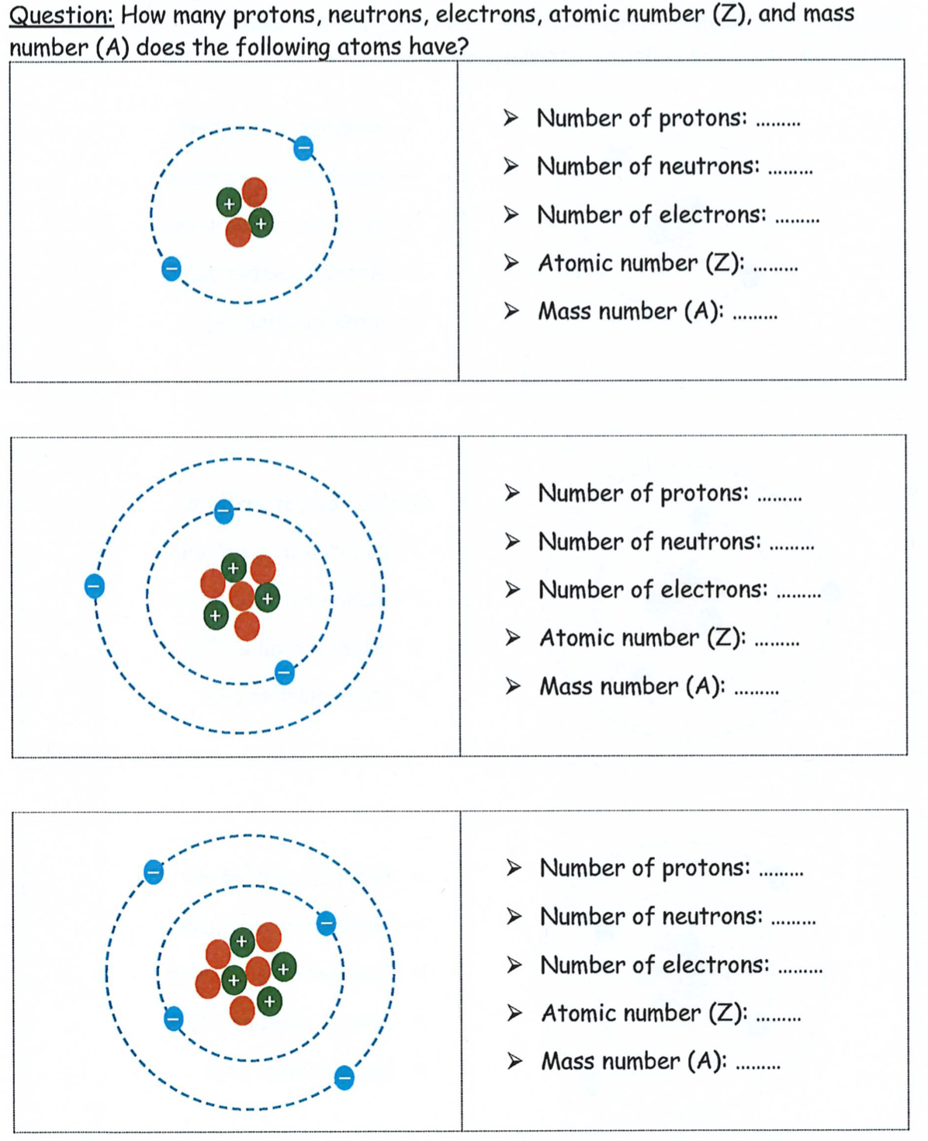

**Question 10**

Complete the table by giving the element name or symbol where appropriate.

**Question 11**

For the following question, circle the correct box.

Which of the boxes contains:

1. Molecules of an element?
2. Molecules of a compound?
3. Atoms of an element?

**End of Test**